|  |  |  |
| --- | --- | --- |
| 5COSC003W Coursework 2 - GROUP template 2020_21  * Use this template to structure the GROUP element of coursework 2. Ensure that the correct information is in each white box. The advice for each box is basic guidance to help you focus your answer. * YOU MUST USE THIS TEMPLATE FOR THE GROUP WORK OF COURSEWORK 2.  The current size of the boxes is not indicating how much you should write; change their size as you need.When you save the file, put your name and registration number in the file name, eg ‘5COSC003W_cwk2_group_Kelly_Garret_12345678.doc’.  * A reminder of plagiarism: If you use bits of another’s group report in yours or if you give your report to another group to use this will be an academic offence called ‘collusion’. * In order for the tutors to be able to assess your work you must ensure the following for your software submission:   - Submit a zipped NetBeans project folder of the **COMPLETE** working project (i.e. the parts of each group member incorporated in one program, not just your part). If you have not been able to incorporate your part with that of the group, then submit only your part – it should be able to run though by itself.  -          Make sure that the submitted project will run using the software provided by the University. Contact your tutor if you have any problems with this.  -          Make sure that the project folder should contain all files necessary to run the program e.g. excel files etc.  -          Make sure that file I/O code does not use absolute file paths.  -          Make sure that the submission contains all usernames and passwords necessary to test the program.  - Each group must upload a video describing the work in a google drive | | |
| **Surname** | Kavus | |
| **Forename** | Burak | |
| **Registration No:** | w1726580 | |
| **By submitting this coursework you agree to the following:** | | |
| I confirm that I understand what plagiarism is and have read and understood the section on Assessment Offences in the Essential Information for Students. The work that I have submitted is entirely my own. Any work from other authors is duly referenced and acknowledged. | | I confirm |
| **List here the other members of your group** | Ciaran Lyne, Aykut Inalan, Steven Naaba, Tevin Awuakye | |

|  |  |
| --- | --- |
| Application Front End (HCI)– group part (10 marks)(if you have not been able to incorporate your work in the group project do not fill in this section, instead fill in section 1a below) | |
| **Guidance:** Attach here a screenshot of the front end of your application, incorporating the elements from each group member.   * Sum up all the main **HCI** issues of the application you have addressed and how they were addressed within the group, in particular as the individual elements came together. Include any HCI issues still remaining. * Comment on how well all parts of the application are linked * Marking of this section will also include the defence of your work during the demonstration | |
| **Members of the group**  **that worked in this:** | **Ciaran Lyne** |

The application can be split up into two sections in terms of human computer interaction: the pre-login panels and the main application panels. The approach and methodology used in both the sections is the same; allow for the user to access whatever they may want to in an intuitive way and in as few button clicks as possible. However, the aim of these two stages is where there is variation so we will look at them separately.

To begin, we have the pre-login panels. These consist of the login and registration pages of the application.

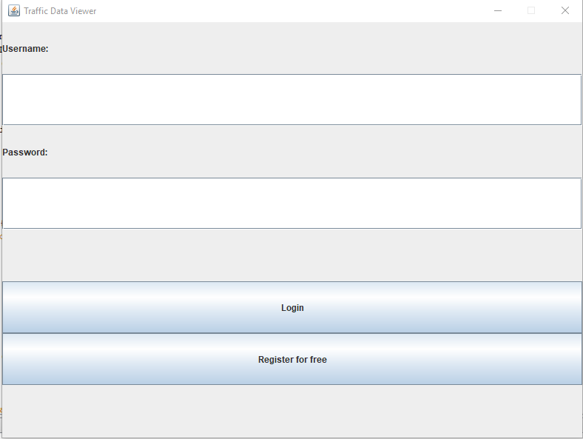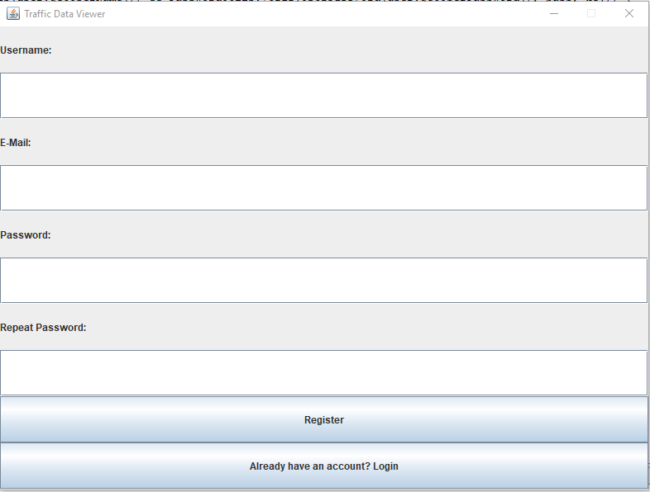

A possible issue here that’s quite apparent from the start is the overall “prettiness” of the application. It’s very simple and plain with every label, text box and button having very clear, obvious use. It might not be the best looking in the world but what it is, is practical. When designing a UI, the intention of the application must be kept in mind and in this case we are creating a utility to display traffic data, not something that’s most likely going to be for the mass market therefore a utilitarian approach is warranted. The users of this application will most likely be more interested in the data than anything else, so we need to design in a way that allows for the quickest, easiest access to the data.

f

The “Register for free” and “Already have an account? Login” buttons allow for easy transition between the two panels in this stage so even though login may be the page that opens initially, a user wishing to register would have no problem instantly noticing the link and being able to continue on their journey as a user.

Upon logging in, the user will be greeted with the second part of the application, the main application panels.

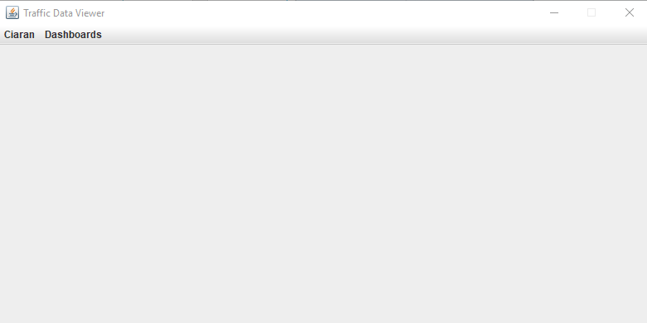

You may have noticed it’s a little bit empty. This is by design, the menu at the top of the screen allows for intuitive access to the links to different pages. The “Dashboards” menu will drop down a list of all the dashboards available to the user. I’m currently logged into the account “Ciaran” and therefore my app menu displays my name as its menu option, adding a nice bit of personalisation to the program without interfering with the utilitarian ideals expressed earlier.

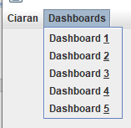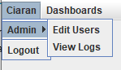

As the admin sub menu can be opened by hovering over it, every panel in the application can be accessed within 2 clicks of logging in. This shows once again the priority of usability over all else.

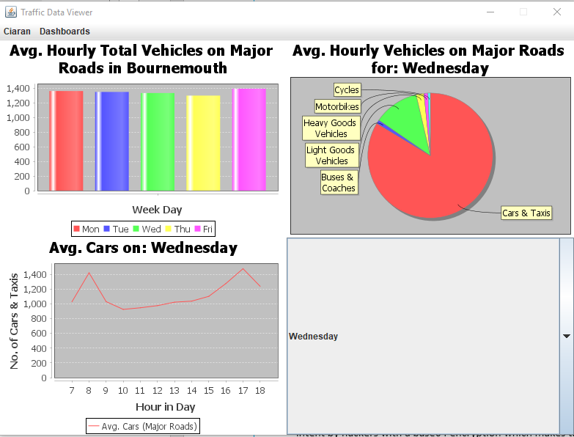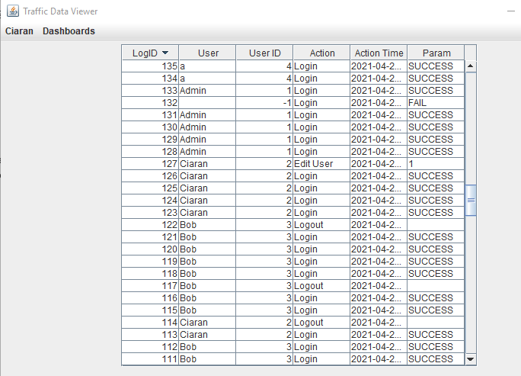

The dashboards and tables are designed in a way whereas much relevant information is displayed to the user as possible without feeling cluttered. Possible room for improvement could come through the addition of a tabbed view for the dashboards when multiple graphs are present but this would sacrifice the ability to have a direct comparison between the graphs without any button clicks.

|  |  |
| --- | --- |
| Application Front End (SECURITY)– group part (10 marks) | |
| **Guidance:**   * Sum up all the main **security** issues of the application and how they were addressed   and any security risks still remaining   * Marking of this section will also include the defence of your work during the demonstration | |
| **Members of the group**  **that worked in this:** | **Aykut Inalan, Ciaran Lyne** |

* **SQL Injection**

Prepared statements are a method which can be used so that statements passed into SQL are treated in a safe manner. We use these through our implementation wherever the user is passing strings that need to be sent to the database. By doing this we prevent someone from entering a string and modifying the intended statement. Examples of this can be found in the select statements used when testing usernames and emails in our login and registration SQL.

* **Security / Data Breach / Passwords**

We can use passwords to protect and make users prove who they are before accessing an online resource, this information is stored inside a table called ‘User’ which then can be accessed to show all the registration information of the user. We made sure that we have encrypted the password with a base64 Encryption therefore even if an attacker achieves a method to receive such personal information, they would not be able to decrypt it without the decryption key.

Our program also documents user’s log information therefore if suspicious activity is detected we can easily see when the activity has happened and resolve the issue straight away.

* **Improper input validation**

We do the proper checks to make sure all the information is valid when the user enters information; information such as registration information we make sure that the username, password, and the email are all valid using certified methods to do so. We put a lot of thought into how we wanted to store data even with the CSV reader as keeping null values are better than setting the integer to a 0 which could affect the overall results when presenting the graph.

* **Unsecure Data Storage**

To prevent unsecure data storage, we suggest that to have the database on a local server, but for testing purposes we have the database in the same project file which would not be the case in a real-life application of this program. We made sure to encrypt most of the user’s information that may be used for malicious intent by hackers with encryption based around the javax.crypto library which makes the data practically useless without a decryption key. We also keep the information in separate tables so it stops an attacker from gathering additional information on their target.

|  |
| --- |
| 1a. (only if you cannot fill in part 1 above)Application Front End (HCI) – individual part |
| If you have not been able to connect your part to the group application:   * Attach here a screenshot of the front end of your own implemented part. * Explain why your part has not been able to connect to the group application. * Sum up the main HCI (10 marks) of your part and how they were addressed. * Marking of this section will also include the defence of your work during the demonstration |

|  |  |
| --- | --- |
| Professional conduct: Legal (5 marks) – Group work | |
| **Which group members worked on this:** | Aykut Inalan, Burak Kavus |
| **Guidance:** With the aid of a table list here the legal issues that would affect both the development and the use of your application. You need to support this work with research. The marks in this section also include marks for references (see end of document). | |
| |  |  |  | | --- | --- | --- | | Legal issues | Purpose | How this effects our project | | User privacy | The purpose of user privacy is to protect the user details and prevent the data from being misused by third parties for fraud. | We had to come up with innovative solutions to make sure the user’s data is indeed safe for example a base64 encryption. | | Terms of use and privacy policies | Terms of use and Privacy policies are required as us developers gather personally identifying or private information. | This prevents us from both the client and the developers from using the information for their personal use keeping the user’s information safe. | | Intellectual property ownership | Intellectual property rights are rights given to a person over their creation. | This gives both us and other developers the right to own their own property, also means that we are not able to use property that isn’t free source. |   The data becomes encrypted in base64, this means none of the staff who have access to program have access to the user’s password. The Key to decrypt the user password is stored with the password inside a database even if someone can have access to both the key and the encrypted password there is a private key used to decrypt meaning the possibility of the fragile information being decrypted by malicious intent is close to impossible. We assume that the .db file we have inside out project file is stored on our computers where the client will not have access to it so even the staff will not have access to other passwords.  Another legal issue was the terms of use and privacy policies, we had to make sure that our application conformed to legal and privacy polices so that users of our application felt safe about how their data and personal information is used. We have to let our users known how their information will be used, as we don’t want to have legal issues with our users by not being clear with the terms of use and privacy policies.  Lastly another legal issue is intellectual property ownership we have to put a lot of effort to make sure everything we have put into our code was owned by us; this is very important as intellectual property ownership is a serious legal topic as we do not want to have code taken or developed by other people as it could get us into legal trouble. To make sure we don’t have any intellectual property ownership issues we made sure that all the content that is displayed on our program was properly checked and verified to have no plagiarism and is all our own original work. | |

|  |  |
| --- | --- |
| Professional conduct: Ethical (5 marks) – Group work | |
| **Which group members worked on this:** | Burak Kavus |
| **Guidance:** With the aid of a table list here the ethical issues that would affect both the development and the use of your application. You need to support this work with research. The marks in this section also include marks for references (see end of document). | |
| |  |  |  | | --- | --- | --- | | Ethical Issues | How can we solve them? | Did we solve them? | | Collecting too much information. | By not collecting information that is not necessary to run the app. | Yes we have by not collecting information that isn’t necessary. | | Weak Security. | By having a few different security methods implemented to make sure our security was at minimum good. | Yes we have added a few different methods of security to make sure our user data is safe. | | Bug Fixing. | By fixing any bugs we come across. | Yes we have fixed every bug that we came across. |   One ethical issue that we faced would be collecting too much information we did not want to collect too much information from our users, this is because we didn’t want to indulge in their privacy and personal data too much as we want them to feel safe using our application. So to prevent collecting too much information from our users we decided to only collect their registration details and there log activity, this allowed us to have the data necessary for them to use the application without compromising their information/privacy.  Another ethical issue we faced was having weak security on our application. This is an ethical issue as we don’t need to provide our users with good security however, it will be ethically wrong to have weak security as it will comprise our users data and privacy. So to negate having a weak security system, we used a few things. Firstly we prepared statements in our SQL code which stopped malicious users from using SQL injection and stealing/destroying our database. Another thing we did was encrypt user passwords, this insured that hackers cannot steal our users password data and use it for malicious intents. Lastly another thing we did to stop user passwords from getting stolen, was just hiding the password field meaning other people wouldn’t be able to see what they have written down.  Last ethical issue was bug fixing, this is an ethical issue as do we need to fix bugs which aren’t code breaking? It was up to us if we were to fix bugs that didn’t break the code as they wouldn’t hinder the user experience too much; however, is it ethically correct to release an application with many small bugs. To fix this issue quite simply we decided to fix all bugs we spotted however, large or small so that the users have a better and more enjoyable experience using our app. | |

|  |
| --- |
| References (marks included in each of the main sections) |
| Sections 3 and 4 must be supported by research.List below your sources, using Harvard referencing. Make sure that your references are referred to correctly from the relevant text of your work. **If you are not clear how to reference read:**  **https://www.westminster.ac.uk/library-and-it/support-and-study-skills/guides-and-tutorials/referencing-your-work** Here’s how we’ll assess it:  * No research sources: that’s very bad for level 5 work * There is one source with all information, copied directly as if it’s your own text: that is plagiarism * There is one source with all information, referenced and discussed: that is bad research * There are a few different sources, referenced and discussed in the text: this is getting better * There are quite a few good sources from many different places, referenced and discussed in the text: this gets good marks. |
| **Section 3 references** |
| https://appempire.com/top-5-legal-issues-facing-app-developers/  https://www.crippspg.co.uk/legal-issues-for-app-developers/  https://opengeekslab.medium.com/top-7-legal-issues-to-consider-in-mobile-app-development-c76192f281f3 |
| **Section 4 references** |
| <https://www.infoworld.com/article/2607452/12-ethical-dilemmas-gnawing-at-developers-today.html>  <https://searchsoftwarequality.techtarget.com/tip/5-examples-of-ethical-issues-in-software-development>  https://www.telerik.com/blogs/why-ethical-design-is-critical-for-mobile-app-designers |